María Ángeles de la Vega – Social Worker
International Professional Exchange Program (IPEP) Germany, September 13th to 29th, 2024
Personal Reflections
Through the Council of International Fellowship, I had the opportunity to participate in the IPEP held in Germany in 2024, specifically in the Rhine/Main region with the two cities of Mainz and Wiesbaden. As a social worker from Argentina, I personally feel this experience was a breath of fresh air—a much-needed reconnection with the essence of my profession.
The program itself is intense and demands genuine commitment. Its rhythm—filled with visits to local agencies, constant dialogue, and reflection—requires participants to be fully present, both intellectually and emotionally. It also calls for flexibility and adaptability, as each day brings new contexts, perspectives, and challenges (with the added effort of doing it all in another language). Yet it is precisely this intensity that makes the experience so enriching.
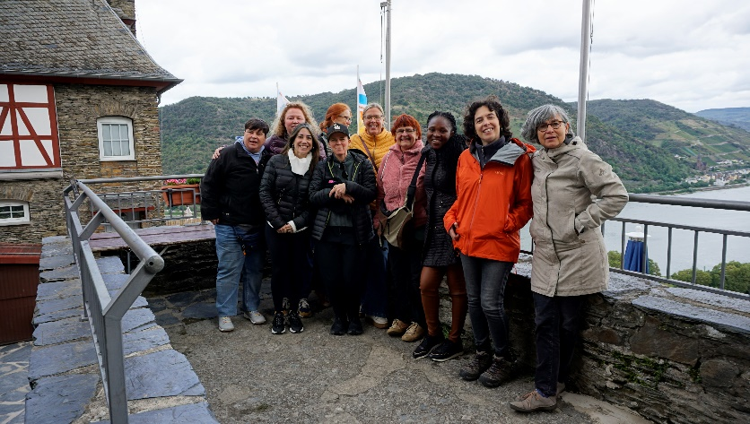
A key element that made this journey exceptional was the remarkable dedication of the host country’s organizing team. Their thoughtful planning went far beyond logistics; they shaped each participant’s experience with care, considering our individual backgrounds, areas of expertise, and even small, random details that made us feel seen and valued. For instance, after I shared my interest in nature, I was placed with a family who rented a beautiful garden where they grew their own vegetables. Along the same lines, knowing my background and expertise in domestic violence risk assessments and gender activism, I later went to live with a woman who runs a prestigious institution with a long history of supporting and advocating for women's and gender-diverse people's rights. As the cherry on top, I had the opportunity to give a lecture there about feminisms in my region. Without a doubt, it was that level of attention that turned the experience into something deeply personal and meaningful.
Equally important was the role of the host families, who opened their homes and private lives to us. Their generosity allowed for deeper immersion into local culture, daily life, and social dynamics. In my case, the families were diverse and beautifully matched to my profile, enriching the experience with warmth and becoming an important support for daily life.
But why was this experience so refreshing? Well, I must say, back home my daily work in the justice system tends to feel routine, alienating, and increasingly complex—especially in recent times, as setbacks in human rights have significantly intensified. Immersing myself in a space where I could engage with fellow professionals from diverse countries and backgrounds—Ghana (running a children's orphanage), Slovenia (working in a domestic violence safe house program), Spain (doing remarkable work related to asylum and migration rights), Australia (working in the health system), and Kyrgyzstan (specializing in project development and excelling in fundraising)—was not only energizing but potentially transformative. It opened a space to temporarily step outside the urgency of suffering, making room to imagine other ways of intervening.
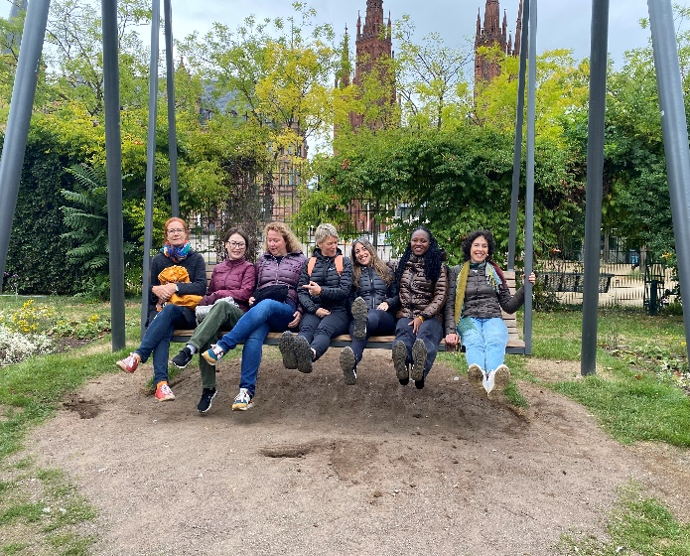
It became clear to me that, despite cultural differences, diverse intervention strategies, and the varying roles social work assumes across nations, there are fundamental values that unite us all: shared struggles, common goals, and a collective horizon rooted in the defence of human rights. The exchange gave me the opportunity to identify shared obstacles and global trends—particularly the rise of anti-rights movements and hate speech—that threaten the very foundations of our work. In this context, I strongly believe international networks like CIF become not only spaces for reflection on micro and macro social processes, but also strategic platforms to envision potential lines of action. In a world marked by deep inequality and fast, uncertain change, these connections become essential to navigate complexity and reaffirm our collective commitment to human rights.
Above all, the program revealed the unique qualities that social workers embody beyond national borders. These qualities—empathy, resilience, a deep commitment to human dignity (and, I think we can all agree on this: a bit of craziness)—enabled us to connect with each other and collaborate with remarkable ease and authenticity.
Furthermore, this experience helped me confront and dismantle certain preconceptions I held about social work and everyday life in the host country and other European contexts, which, from a Latin American perspective, often appear to be less complex or, at least, less encumbered by structural challenges. Taking distance from my own country also allowed me to analyse my national context with greater perspective—recognizing both its challenges and valuing its advances, for example, in the legislative area related to gender and diversity.
In summary, the IPEP arrived at the perfect moment, offering the push I needed to keep embracing—and fighting for—my conviction that a more just world is both possible and necessary. It required commitment and effort, but was 100% worth it. It also reaffirmed my belief in the power of international solidarity and the vital importance of cultivating spaces where our profession can breathe, reflect, and grow. As Brazilian pedagogue Paulo Freire once said, “No one is saved alone, no one saves anyone, we all save ourselves in community.
María Ángeles de la Vega
angeles.delavega89@gmail.com

